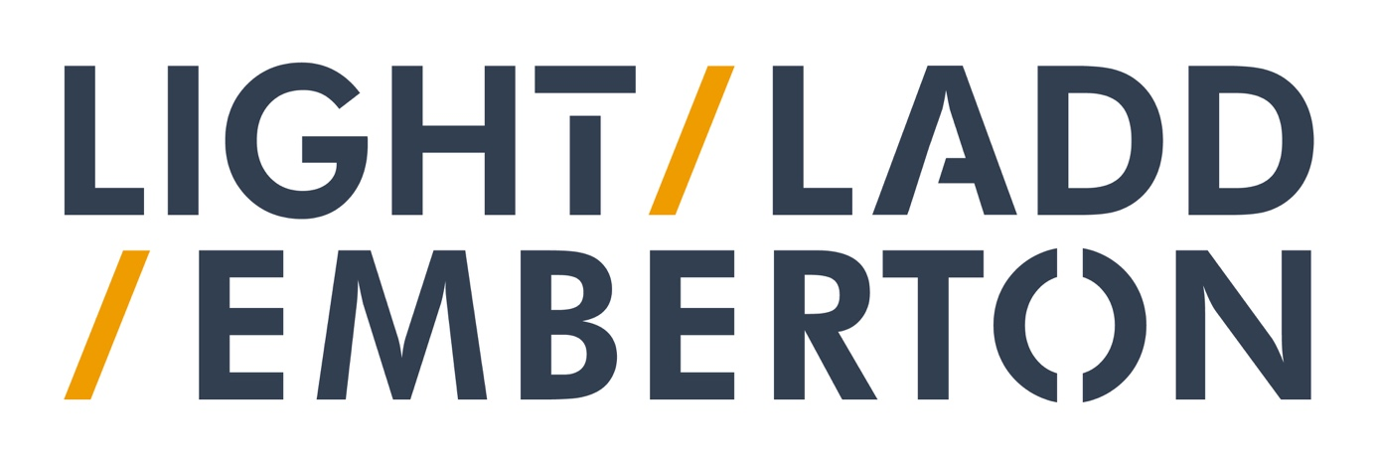
Your personal data
Light / Ladd / Emberton is committed to protecting your privacy and your personal data.
When you attend a class, workshop, talk, performance, rehearsal, or other event, use our online services, or contact us through any channels (e.g. email, website contact us page, social media), we may need to obtain and store your personal data, in order to assist you best.
We may need your home address, email address, telephone number, card payment details, demographic information, online identifiers, next of kin and medical/injury history.
This policy sets out why we require this data, how we store and use your data, and your legal rights to amend or remove your data.
Why we ask for your data:
When you give us your data, we may use it for one or more of the following purposes:
● To let you know about activities which you might be interested in ● To manage, deliver and improve our services
● To monitor access to our services
● Collate anonymous statistics for funders and stakeholders
● To maintain our own accounts and records
● To contact you in the event of an alteration or cancellation of one of our services
● To manage any ticket or course bookings that you make online ● To fulfil our legal and/or regulatory duties
● To process a financial payment

How we use sensitive personal data:
When participating in a class, workshop or rehearsal, we do sometimes ask for sensitive personal data, such as medical history, or emergency contact details for a next of kin. This will only be used to ensure your own safety and wellbeing when participating in one of our classes or projects.
On occasion we will also ask for monitoring information, such as your age, ethnic origin and gender. We collect this information to ensure that we are reaching all parts of the local community, and to meet funding requirements of funding bodies such as the Arts Council of Wales and the Welsh Government. We use this to track attendances which we report to our funders to ensure we are making the best and fairest use of any public investment we are in receipt of. We also use this information to fulfill our commitment to equality, diversity and inclusion. If you do not wish to offer this information you have the right to decline without affecting any relationship with Light / Ladd / Emberton.
How we keep your data secure:
We store your data using secure and password-protected databases, including on our internal systems.
If your data is kept in a physical format, it will be stored securely and then destroyed securely when the data is no longer needed.
Gathering your data on our website/cookies:
We use Cookies on our website to improve how we engage and communicate with you. Cookies are small text files placed on your computer by this website, when you visit certain parts of the Website and/or when you use certain features of the website. All Cookies used by this website are used in accordance with current UK and EU Cookie Law.
Before the Website places Cookies on your computer, you will be presented with a message bar requesting your consent to set those Cookies. By giving your consent to the placing of Cookies, you are enabling Light / Ladd / Emberton to provide a better experience and service to you. You may, if you wish, deny consent to the placing of Cookies; however certain features of the Website may not function fully or as intended.
We automatically collect some information about your visit to the website. This information helps us to make improvements to website content and navigation, and includes your IP address, the date, times and frequency with which you access the website and the way you use and interact with its content.
How long we keep your data:
We will keep your data for a maximum of two years following inactivity i.e. not opening emails. This means we are only holding on to your data for as long as necessary.
Transferring your information abroad:
We use Google Drive and Suite for emails and data storage. Any personal data is hosted on servers outside of the UK and are subject to General Data Protection Regulation.
We use a third party called MailChimp to send marketing emails to you and they are based in the United States of America. The company participates in and has certified its compliance with the Privacy Shield framework, and is committed to treating all personal data received from European Union member countries in accordance with the Privacy Shield framework’s principles.
Receiving marketing communications:
We will only contact you with marketing communications if you explicitly give us permission to do so. You have the right to change or revoke this consent at any time by contacting a member of the Light / Ladd / Emberton team or using the unsubscribe option in the marketing emails.
If you give us permission, we’ll use your email address and/or postal address to contact you with news about Light / Ladd / Emberton, to inform you about future events, or to let you know about our fundraising campaigns.
If you give us express permission to do so, we may share your contact details with specific artists or partner organisations we work on projects with, so that they can keep you informed about their work. This consent can also be changed or revoked at any time. No other third parties will receive your data unless you consent to it.
Third Party/External services:
We use several external communications channels or third party companies which you need to be aware of. This is in order to be able to reach you. These Websites may, from time to time, provide links to other websites. We have no control over such websites and are not responsible for the content of these websites. We recommend reading their privacy policy prior to using them. We adhere to their Privacy Policies.
Websites/web services we use to communicate are:
● Mailchimp (email) - https://mailchimp.com/legal/privacy/
● Squarespace (website)
● Facebook - https://www.facebook.com/policy.php
● Instagram - https://help.instagram.com/519522125107875 ● Twitter - https://twitter.com/en/privacy
● Youtube -
https://www.youtube.com/howyoutubeworks/policies/community-guidelines/
We also work with a number of theatre venues on tour. Please do read their Terms and Conditions and Privacy Policies when buying tickets.
Your rights:
You have the legal right to access your data, or to change your data if it is inaccurate. You also have the right for the data to be removed, unless we have a legitimate reason for keeping it. In order to do this, please put your request in writing by email to lightladdemberton@gmail.com We will respond to all requests within 4 weeks of receipt.
If you have signed up to our mailing list, you have the right to opt-out of communications at any time. You can do this either by contacting us at lightladdemberton@gmail.com or in the case of email marketing, by unsubscribing using the link at the bottom of each email.
If you have any queries about your data and your rights, you can contact us, addressing your query to Laura Drane (Producer) via lightladdemberton@gmail.com, or in the case of email marketing, by unsubscribing using the link at the bottom of each email or calling +44(0)7957622623.
If you are not happy with our response, you also have the legal right to complain to the Information Commissioner’s Office.

